SPRINT-1

|  |  |
| --- | --- |
| Date | 3 NOVEMBER 2022 |
| Team ID | PNT2022TMID31860 |
| Project Name | Real Time River Water Quality Monitoring And  Control System |

Step-1: Creating IBM Cloud and Using its Service.

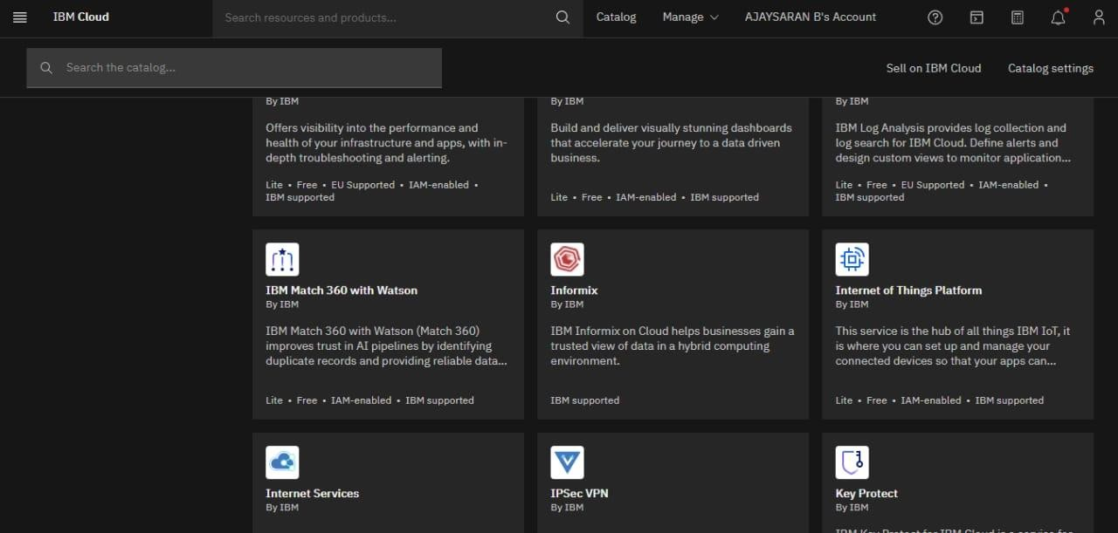

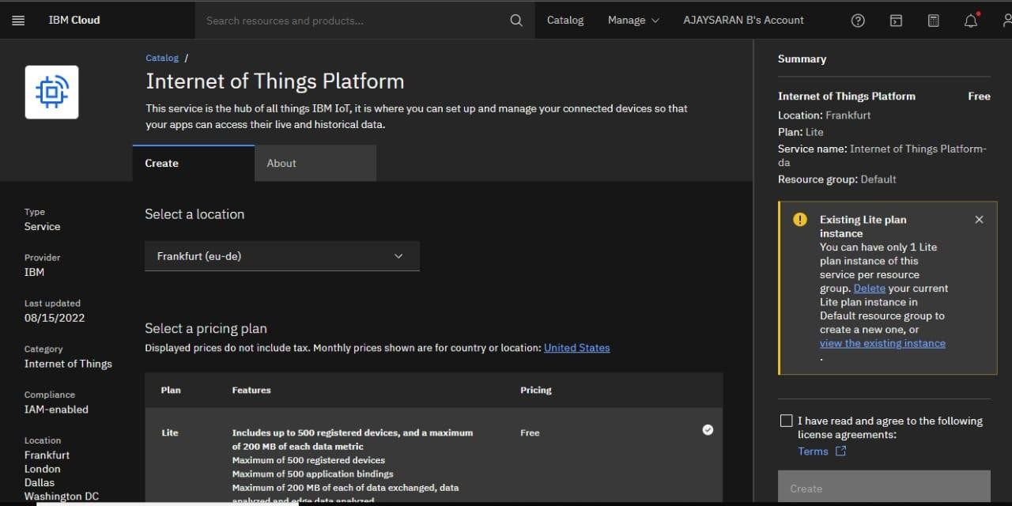

hence launching IBM Watson IOT platform.

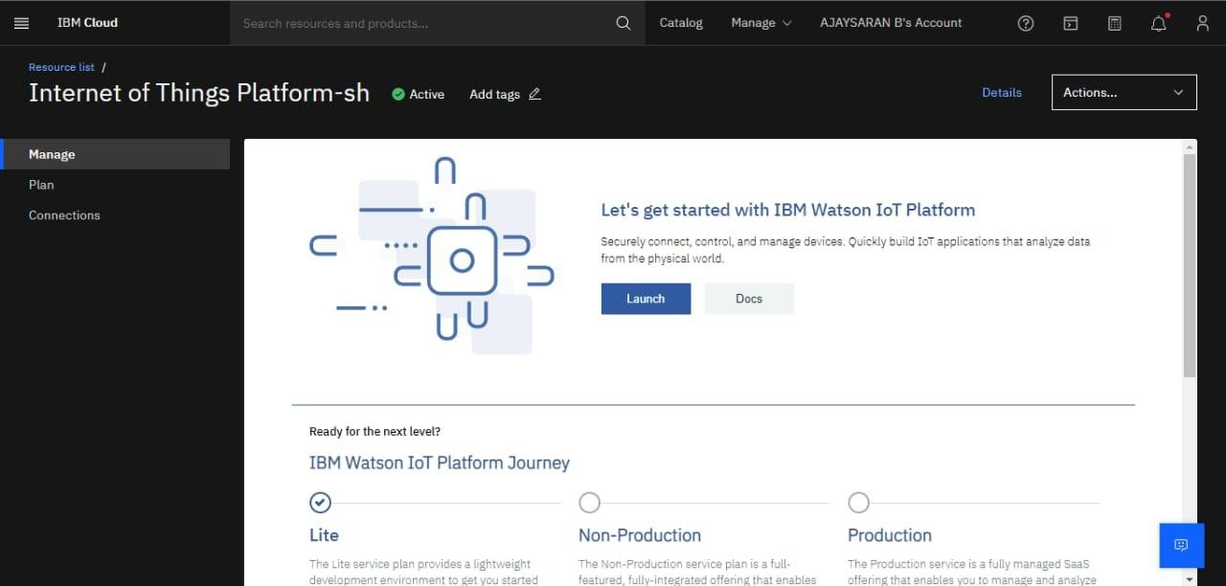

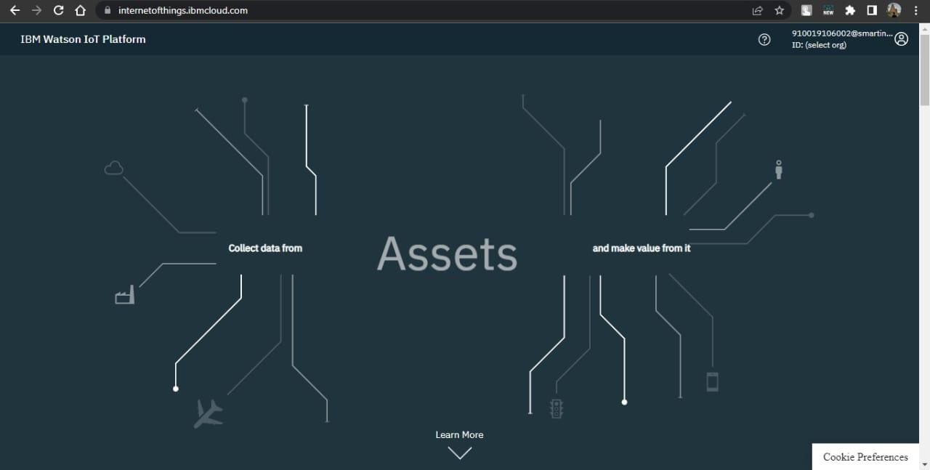

Platform and get the device credentials.

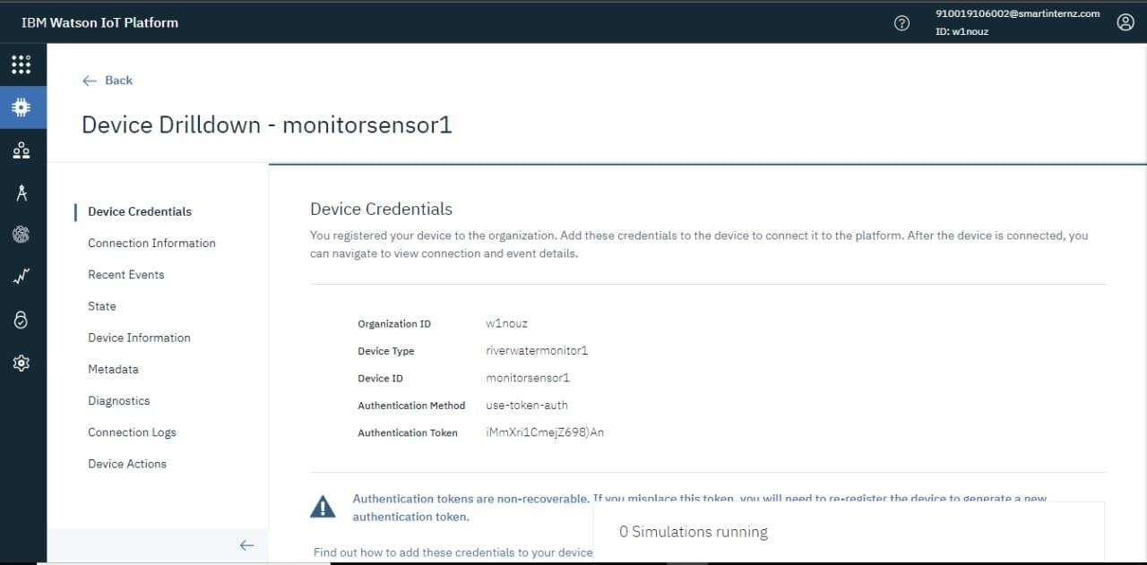

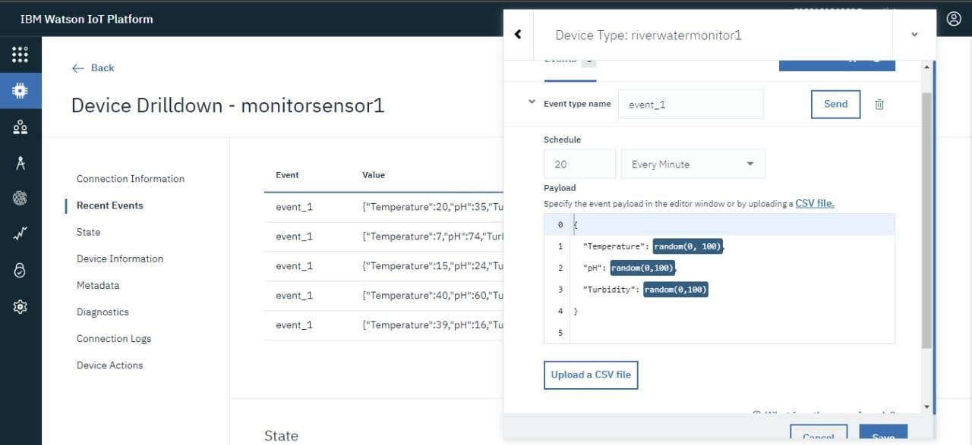

The simulation shows the Temperature, pH and Turbidity value.

